Exploratory data analysis
Exploratory data analysis of Airbnb listings in NYC

This data analysis report is to show airbnb insights from New York City in 2019. In this, I selected a subset of 50 listings from the full dataset of 50,000 to make the analysis more manageable, and provide a clear demonstration of data cleaning and analysis techniques while making the dataset still relevant.

Listings per neighbourhood
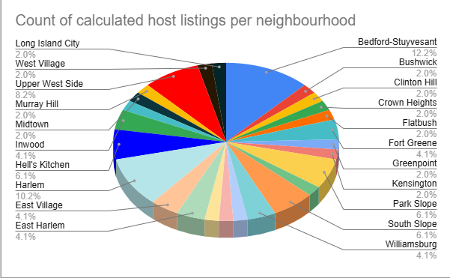
The pie chart above shows the number of Airbnb listings in each neighbourhood in the sample of 50 listings.
We can conclude that “Bedford-Stuyvesant” holds the highest number of listings with a count of 12.2%, whilst “Long island city” ,”West Village”, “Murray Hill”, “Midtown”, “Bushwick”, “Clinton Hill”, “Crown Heights”, “Flatbush”, “Greenpoint” and “Kensington” each has a low listing of 2%.
Bedford-Stuyvesant has the highest number of listings which indicates that hosts are more concentrated in this neighbourhood than others. The dataset does not provide information about guest demand or reasons for this concentration, so conclusions about popularity or tourism cannot be drawn from this sample alone.

Average price per night by room type
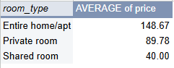
This pivot table shows the average price of room types per night with entire homes / apartments being the most pricey, followed by private rooms and then shared rooms being the cheapest. This indicates that within the sample, the average price per night varies on the room type, suggesting a relative relationship, where larger units tend to be priced higher than smaller or shared accommodations.

Patterns and trends
Bedford-Stuyvesant has the highest number of listings compared to other neighbourhoods which shows that hosts are more concentrated in certain areas than others.
The average price per night varies by the room type, where entire homes / apartments are the most expensive, private rooms being mid range and shared accommodations being the least expensive.
Within the sample, both listing distributions and pricing show a pattern where some neighbourhoods dominate the listings, and the price is linked to the room type.

